**Belgravia Matt Abanilla Marble Effect Tiles:**

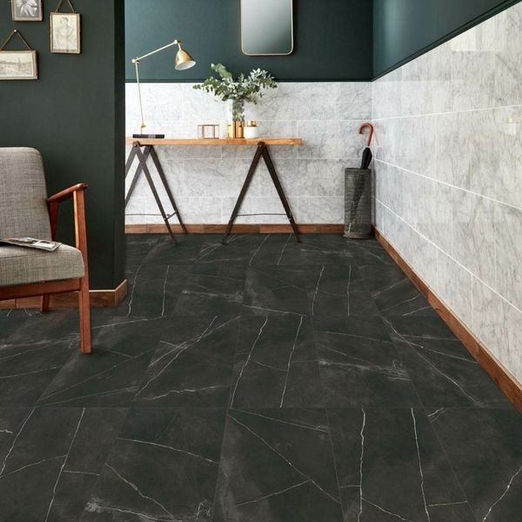

## **Product Description**

Inject a luxurious new look into your interiors this season with these gorgeous Belgravia Matt Abanilla Marble Effect Tiles. They have a dark backdrop with light characterful veining. Made from porcelain, they can be used on both walls and floors. They're a large format tile, which gives them a grand appeal, and they have an opulent matt finish.

**What's special about these tiles?**

> Large format design  
> Opulent matt finish  
> Luxurious realistic marble effect look  
> Made from durable porcelain  
> Versatile - perfect for walls and floors  
> Suitable for use with underfloor heating

## **Product INFO**

* Product ID: 39686
* Tiles Per SQM: 1.3888888888889
* Sale by: Per SQM
* Size: 600x1200x10mm
* Weight: 18.84 KG
* Material Type: Porcelain
* Finish: Matt
* Colour: Black/Charcoal
* Suitability: Floors, Walls
* Grade: 4
* Rectified Edge: Yes
* Underfloor Heating: Yes
* Document: [Tile Variations](https://m2.wallsandfloors.co.uk/media/amasty/amfile/attach/39686.pdf),[Tile Variations](https://m2.wallsandfloors.co.uk/media/amasty/amfile/attach/39687.pdf),[Tile Variations](https://m2.wallsandfloors.co.uk/media/amasty/amfile/attach/39688.pdf),[View Layout Designs](https://m2.wallsandfloors.co.uk/media/amasty/amfile/attach/Walls-and-Floors-uffmoor-design-recommendations.pdf)
* Thickness (mm): 10

**Cosmic Cloud White Lappato Floor Tiles:**

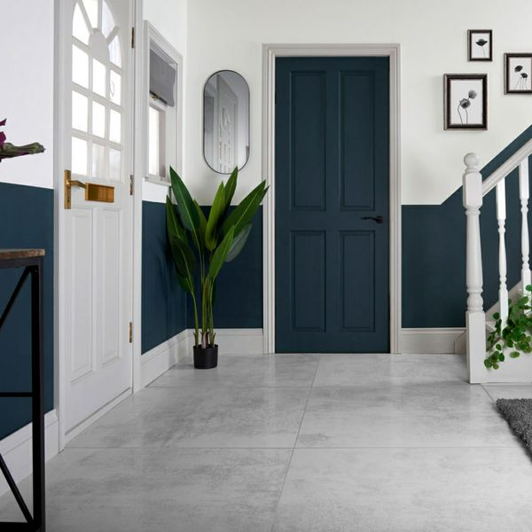

## **Product Description**

Go for a contemporary, industrial style with these Cosmic Cloud White Lappato 898x898 Tiles! They feature a metallic look that is a striking feature for modern interior design in any room. With a lappato finish and unique rusted illusion, they add texture and dimension instantly across wall and floor spaces.

**What's special about these tiles?**

> Unique rusted look for a textured design

> Semi-polished, lappato finish

> Metallic feel

> Large format design

> Durable porcelain body

**Try before you buy**

If you'd like to take a closer look, why not order a sample tile? Samples are a great way to get a feel for a tile's true colour and texture, and you can see how it looks in your chosen room!

## **Product INFO**

* Product ID: 44767
* Tiles Per SQM: 1.2400732139225
* Sale by: Per SQM
* Size: 898x898x10mm
* Weight: 19.30 KG
* Material Type: Porcelain
* Finish: Semi-Polished
* Colour: White
* Suitability: Floors, Walls
* Grade: 4
* Rectified Edge: No
* Underfloor Heating: Yes
* Thickness (mm): 10

**Yuri™ Graphite 90% Recycled 1175x1175 Tiles:**

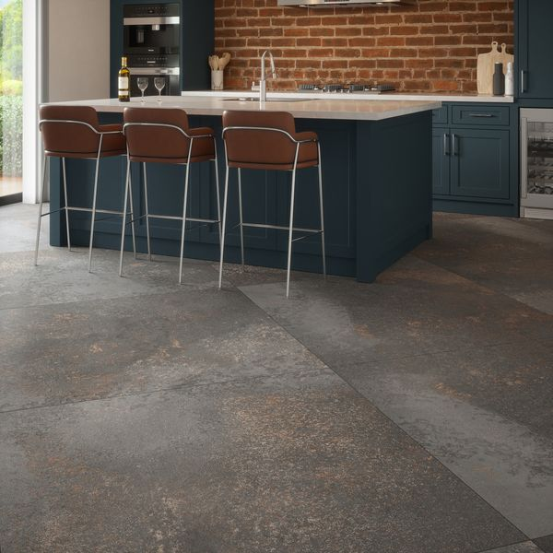

## **Product Description**

Yuri™ Graphite 90% Recycled Tiles have a raw, industrial feel that emanates the look of salvaged metals and concrete, with small details in their appearance like abrasions and oxidisation. Reminiscent of British cliffs moulded by rain and sea, varied shades of carbon grey collide together with metallic rust-browns to create a mottled look, alive with character and charm. Made from 90% recycled raw materials, water and minerals, with an eco-friendly manufacturing process and no compromise on quality and finish, these tiles are highly variegated, with multiple faces for a unique look. Available in two sizes, these tiles feature an R10 anti-slip surface, also PTV +36, so they are suitable for any area of your home.

**What’s special about these tiles?**

> Made from 90% recycled materials

> Infinite variations for a unique look

> Rectified edges for a sleek, seamless look

> R10 anti-slip surface and

> Subtle matt finish

## **Product INFO**

* Product ID: 45013
* Tiles Per SQM: 0.72430964237211
* Sale by: Per SQM
* Size: 1175x1175x11mm
* Weight: 48.08 KG
* Material Type: Porcelain
* Finish: Matt
* Colour: Grey
* Suitability: Floors, Walls
* Area Of Usage: Internal, External
* Grade: 4
* Rectified Edge: Yes
* Underfloor Heating: Yes
* Anti Slip Grade: R10 / 19-27 Degrees
* Thickness (mm): 11

**Largo Mist White Tiles:**

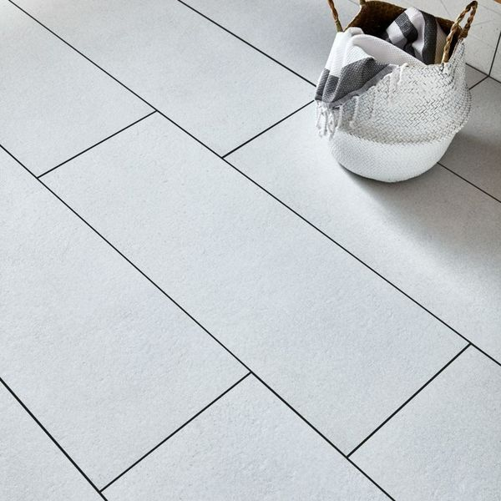

## **Product Description**

These XXL large-format Mist Tiles have a brushed limestone effect design with a lifelike texture. Made from porcelain, they're very durable and can be used on both walls and floors. They have a matt finish and an R10 anti-slip finish.

The idea of 'bringing the outdoors in' has never been more popular, and these tiles are perfect for creating the natural look in a bathroom, kitchen, living area, hallway or bedroom.

**What's special about these tiles?**

> Made from porcelain

> R10 anti-slip finish

> Brushed limestone effect design

> Matt finish with lifelike texture

**Take a closer look**

For a closer look, why not order a sample tile? Unlike other tile companies that only send out tiny cut samples, we send out the full-size tile so that you get the full effect. Our sample tiles come with Fast Free Delivery.

## **Product INFO**

* Product ID: 36975
* Tiles Per SQM: 3.3670033670034
* Sale by: Per SQM
* Size: 330x900x10mm
* Weight: 6.47 KG
* Material Type: Porcelain
* Finish: Matt
* Colour: White
* Suitability: Floors, Walls
* Grade: 4
* Rectified Edge: Yes
* Underfloor Heating: Yes
* Anti Slip Grade: R10 / 27-35 Degrees
* Thickness (mm): 10